**Project Development Phase**

**Delivery of Sprint - 2**

|  |  |
| --- | --- |
| **Date** | 07 November 2022 |
| **Team ID** | PNT2022TMID10041 |
| **Project Name** | AI based discourse for Banking Industry |

**CreatingLoanAction**

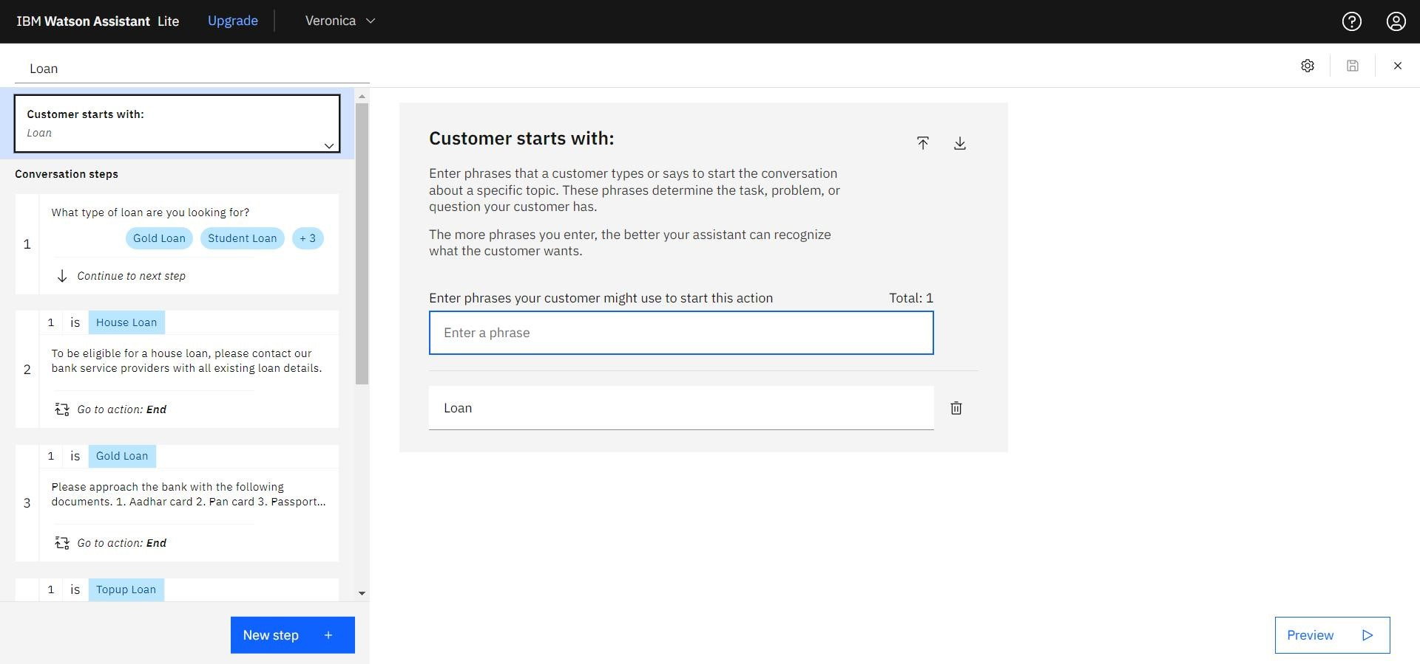Create a new Loan Action Skill

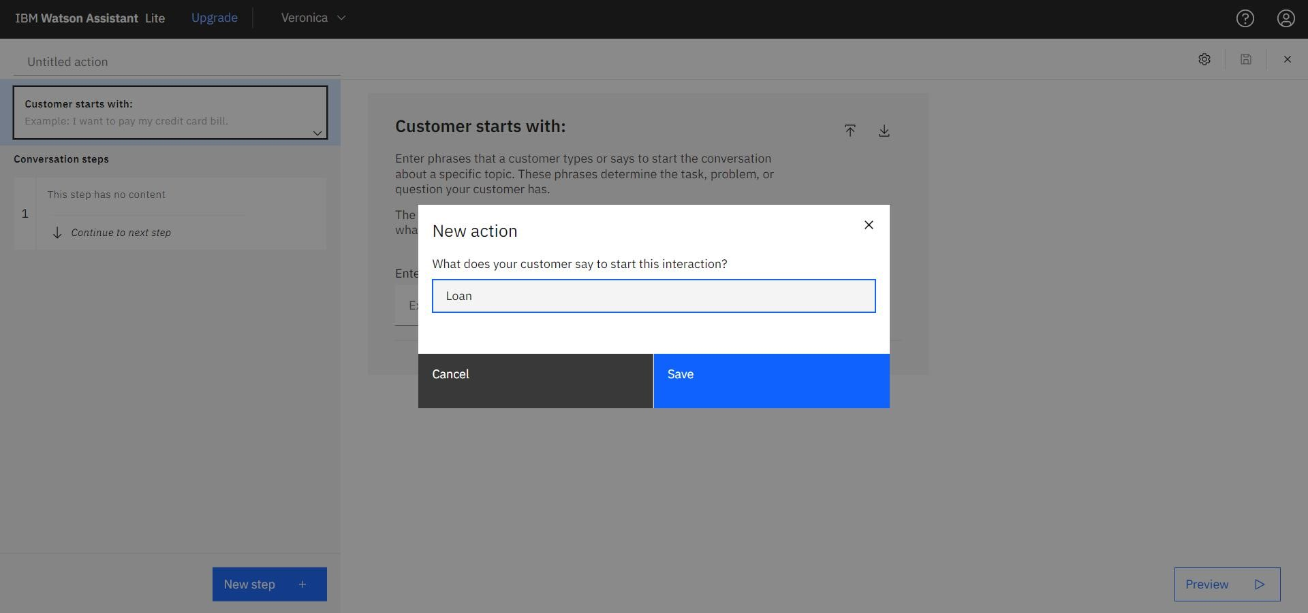

Adding steps in loan action to handle customer queries regarding Housing loan, Gold loan, Top-up loan, Student loan, and Vehicle loan.

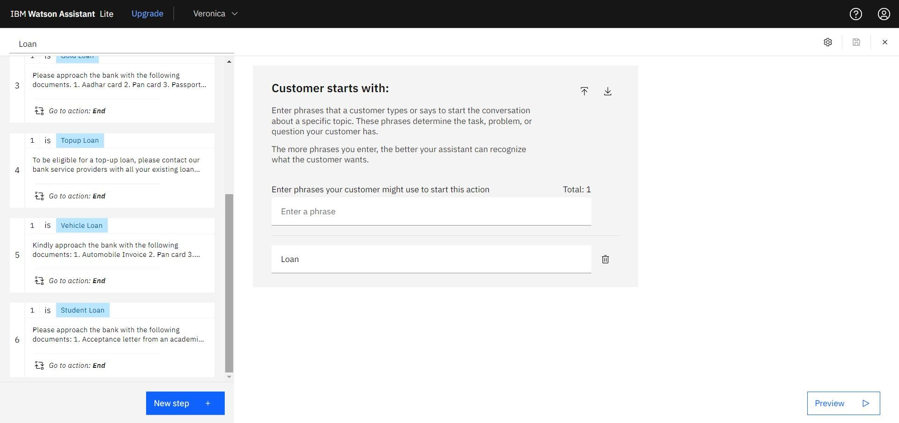

**Creating Current Account Action**

Create a new action skill Current, for the current account action.

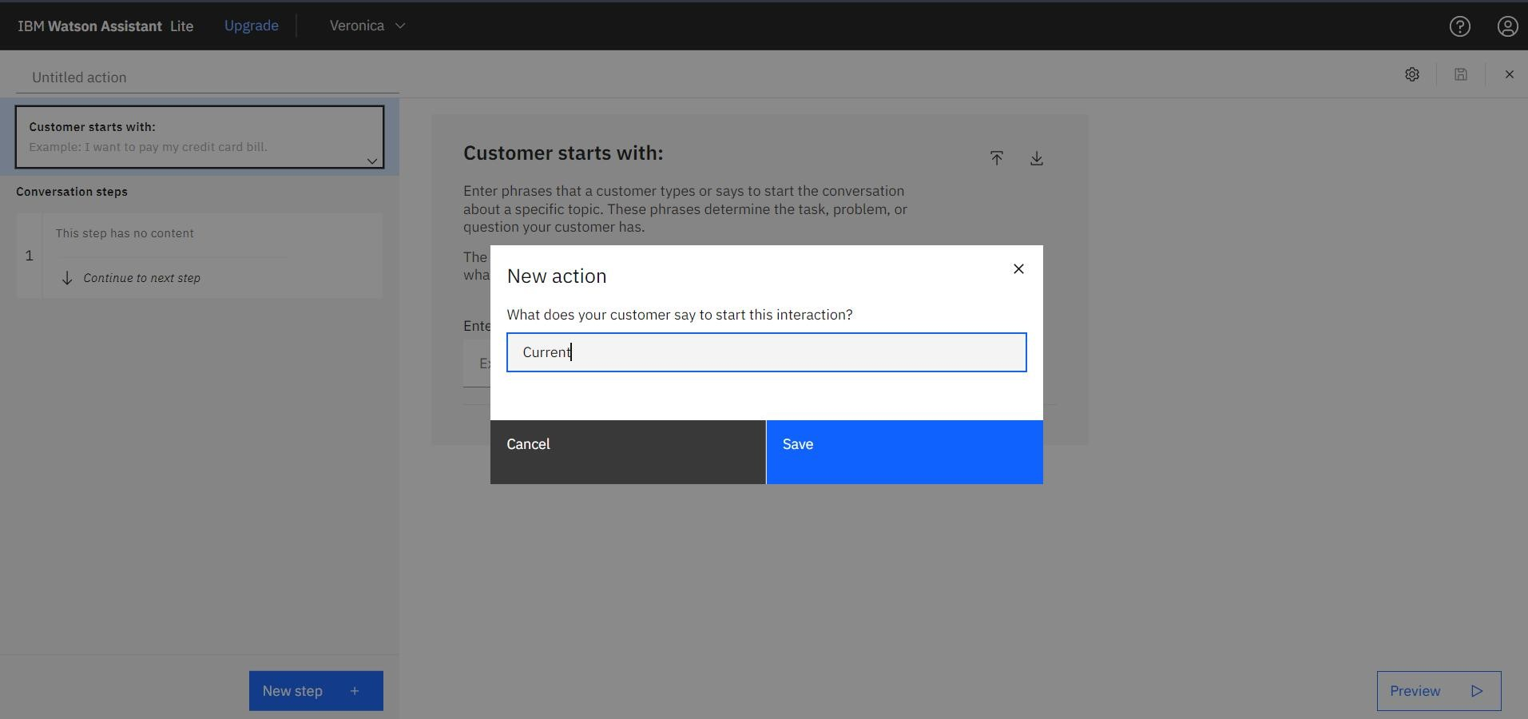

Adding steps in Current action to handle customer queries regarding Partnership and Proprietorship account creation.

